مراجعة ليلة الامتحان للصف الخامس الابتدائي ( الفصل الدراسي الأول )
إعداد / مستر رجب أحمد ragab.ahmed28@yahoo.com
***السؤال الأول في ورقة الامتحان
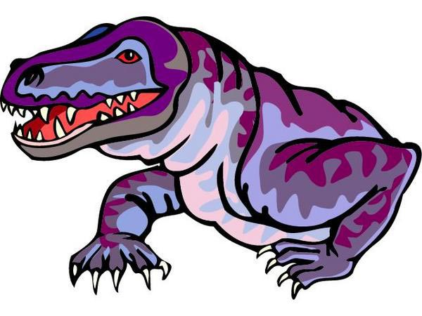

1- Listen to the words and circle the right pictures:
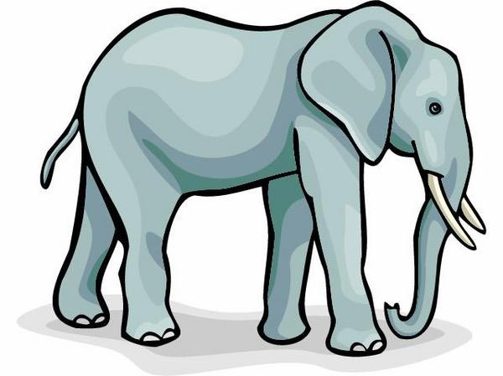
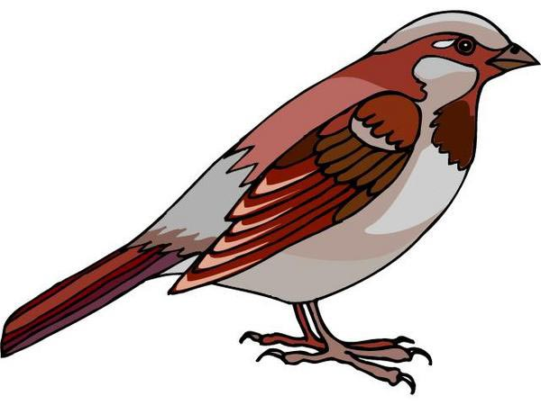
a)
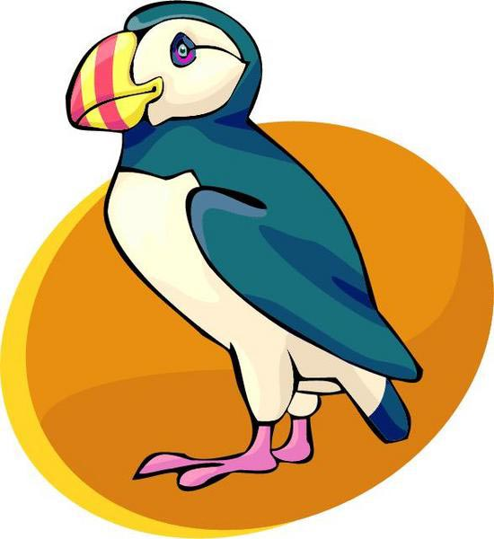
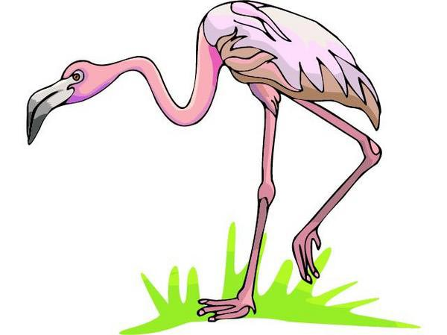
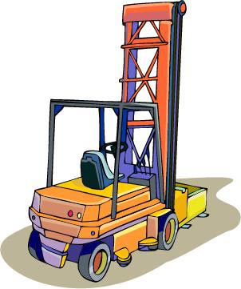
b)
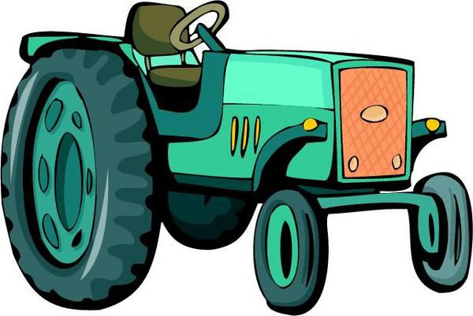
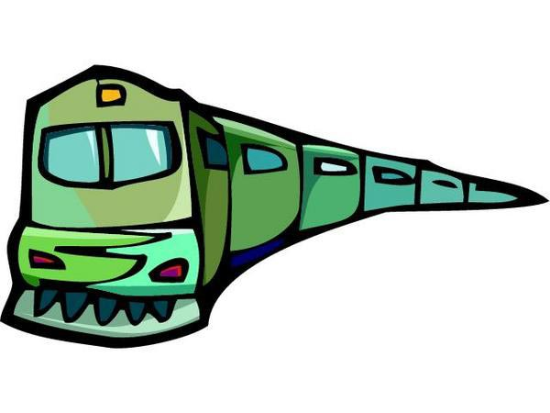
c)

***السؤال الثاني في ورقة الامتحان

2- Listen to the sentences and circle the right pictures:

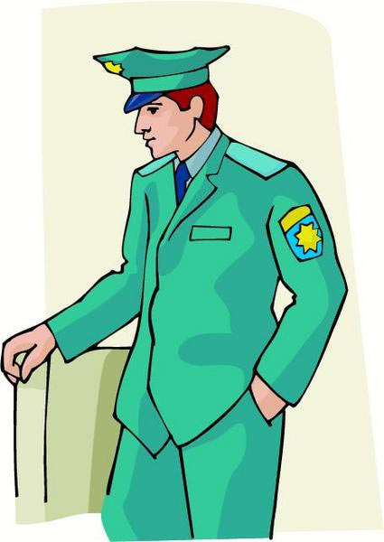
a)

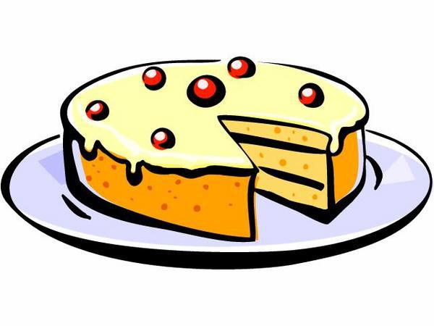
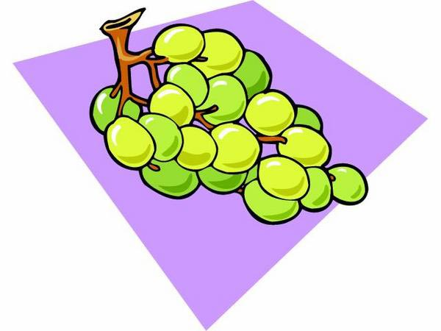

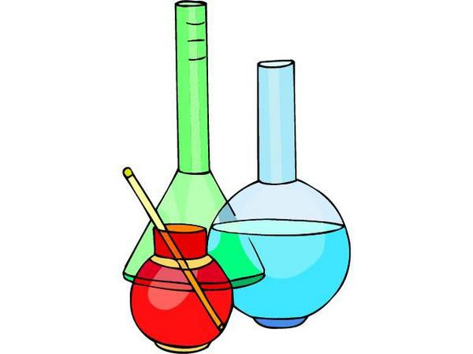
b )

c )

السؤال الثالث في ورقة الامتحان:

{ 1 }
- father | Plane | mother | sister
- like | hippo | tiger | lion
- art | science | maths | vegetables
- Sunday | Monday | Friday | English
{ 2 }
- book | dress | pen | bag
- worker | teacher | nurse | box
- apple | cake | science | ice cream
- short | ear | hand | eye
{ 3 }
- red | blue | cup | green
- Arabic | Saturday | Sunday | Monday
- play | dirty | do | listen
- cat | hippo | zebra | table
{ 4 }
- October | November | May | English
- brother | father | art | mother
- shirts | vegetables | dresses | skirts
- dinner | go | do | have
{ 5 }
- mouse | cat | dog | ship
- pink | aunt | uncle | cousin
- school | factory | field | bottle
- cup | bottle | white | tube

السؤال الرابع في ورقة الامتحان:
2- Match the words with the answers:
- 1 -
{ A } | { B }
1-What have Doaa and Ali got? | a) No, it can’t.
2-Can a monkey read? | b) Yes, this is my grandfather.
3-Where do you live? | c) The farmer drove a tractor.
4-Is this your grandfather? | d) They have got books.
 | e) I live in Cairo.
- 2 -
{ A } | { B }
1- Can you see number 6? | a) No, I don’t.
2- Do you like art? | b) It is on the desk.
3- Where is the CD? | c) Yes, I can.
4- What did you see yesterday | d) They are next to the door.
on the farm? | e) Animals and birds.
- 3 -
{ A } | { B }
1- What has Magdy got? | a) Yes, I do.
2- Do you like unhealthy food? | b) He went to the zoo.
3- Where did Ali go yesterday? | c) He’s got a pen.
4- Is Heba hungry? | d) At six o’clock.
 | e) No, she isn’t.
- 4 -
{ A } | { B }
1- Can you make tea? | a) Yes, he did.
2- How are you? | b) I’m fine, thanks.
3- What can Salwa see? | c) She can see a plane.
4- Did Magdy help his mother? | d) No, I can’t.
 | e) I can hear a bus.
طريقك إلي القمة
مستر رجب .....

السؤال الخامس في ورقة الامتحان:
3- Read and put a (✓) or a ( × ):

I am Ali. I’m ten years old. Today is my birthday. My mother is in the kitchen. She is a clever cook. She cooks food for my birthday. My friends and I like healthy food. We don’t like unhealthy food.
1-Ali is ten years old. | ( )
2-Today is Ali’s birthday. | ( )
3-Ali’s mother is a clever doctor. | ( )
4- Ali’s friends like unhealthy food. | ( )
3- Read and choose a, b, or c :

My name is Mona. I am twenty – three years old. I teach English in a primary school. Rasha is my sister. She is twenty-four years old. She likes Arabic. I like strawberries but Rasha likes grapes. We like volleyball.
1-Rasha teaches…………….
a) |  |  | Arabic |  |  | b) |  |  | maths |  |  | c) |  |  | English
2-Rasha likes…………….
a) |  |  | strawberries |  |  | b) |  |  | grapes |  |  | c) |  |  | cucumbers
3-Mona is…………… years old.
a) |  | 20 |  |  | b) |  |  | 23 |  |  | c) |  |  | 24
4- Heba and Rasha like ……………. .
a) | basketball |  |  | b) |  |  | football |  |  | c) |  |  | volleyball

السؤال السادس في ورقة الامتحان:
4- Finish the sentences with words from the list:

- 1 -
can – idea – dirty – book – can’t
1- The opposite of “clean” is ……………. .
2- That is a good ……………. .
3- Crocodiles ……………. jump.
4- Where is the …………….?
- 2 -
market – like – farm – likes – car
1- What did you see on the …………….?
2- Ali ……………. pizza.
3- Do you ……………. maths?
4- You can buy the dresses at the ……………. .
- 3 -
is – What – English – can – elephant
1- An ……………. has got big ears.
2- My favourite subject is ……………. .
3- What ……………. the time?
4- ……………. can you see?
- 4 -
good – play – does – teacher – farm
1- A farmer works on a ……………. .
2- Let’s ……………. basketball at five o’clock.
3- My mother is a ……………. .
4- Does Heba like Egypt? – Yes, she ……………. .

السؤال السابع في ورقة الامتحان:
5- Rearrange the following words to make meaningful sentences:

- 1 -
1- Heb’s - Today – birthday – is.
- …………………………………………………………………………………
2- like – you – Do – food – healthy?
- …………………………………………………………………………………
3- drove – The – tractor – a – farmer.
- …………………………………………………………………………………
- 2 -
1- can’t - Crocodiles – run.
- …………………………………………………………………………………
2- elephant – This – an – is.
- …………………………………………………………………………………
3- has – My – a – uncle – farm.
- …………………………………………………………………………………
- 3 -
1- are – There – of – lots – cows.
- …………………………………………………………………………………
2- boys – Can – see – you?
- …………………………………………………………………………………
3- subject – My – favourite – Arabic – is.
- …………………………………………………………………………………

السؤال الثامن في ورقة الامتحان:

ضع علامة الاستفهام بعد الحاجات اللي جاية دي :
Verb to “do”
Do?
Does?
Did?
Verb to “be”
Is?
Are?
Was?
Were
Verb to “have”
Has?
Have?
Had?
Model Verbs
Can?
Must?
Should?
“Wh” questions
What?
When?
Where?
Why?
How?
Who?

The Comma , الفاصلة
1- تستخدم الفاصلة بعد كلمة Yes أو No :
-Yes, he is.
- No, he isn’t.
2- عند مخاطبة شخص ما ( غالباً الاسم في آخر الجملة ) :
- Come here, Nabil.
What can you see, Ahmed?-
The apostrophe ‘ الفاصلة العليا
تستخدم الفاصلة العليا مع أربع حروف وهم:
’m – ’s – ’t – ’re – ’ve

1- تستخدم في حالة الملكية :
Ahmed ‘s book كتاب أحمد
Ahmed ’s bagحقيبة أحمد
2- تستخدم في الاختصارات مثل:
I'm - He's - She's - We're -We’ve - They’re - It’s - Let's - isn't - aren't - hasn't - haven't - What's - Who's - How're - That's - o'clock

6- Punctuate the following sentences:

- let s visit siwa next week
- …………………………………………………………………………………………………………… .
- did dina go to alexandria last summer
- …………………………………………………………………………………………………………… .
- the pyramids are in giza
- …………………………………………………………………………………………………………… .
- my friend hesham is from alexandria
- …………………………………………………………………………………………………………… .
- we ve got english test next week
- …………………………………………………………………………………………………………… .
- did ali go to aswan on holiday
- …………………………………………………………………………………………………………… .

6- Punctuate the following sentences:

- what did dina see in cairo
- …………………………………………………………………………………… .
- have ali and mona got brothers
- …………………………………………………………………………………… .
- rasha, adel and nabil saw monkeys in the zoo
- …………………………………………………………………………………… .
- ayman is heba s husband
- …………………………………………………………………………………… .
- my uncle s farm is in sharkia
- …………………………………………………………………………………… .
- dina s father works in cairo
- …………………………………………………………………………………… .
- mr ragab is a teacher of english
- …………………………………………………………………………………… .
- this is ahmed s family
- …………………………………………………………………………………… .
- 10rabic10 and 10rabic are my favourite subjects
- …………………………………………………………………………………… .
- let s visit port said next Friday
- …………………………………………………………………………………… .
- what happened ahmed
- …………………………………………………………………………………… .
السؤال الأخير خط والسلام عليكم ورحمة الله وبركاته
مع تمانيتي لكم بالنجاح والتوفيق
Mr Ragab Ahmed

