Second term
Oliver Twist

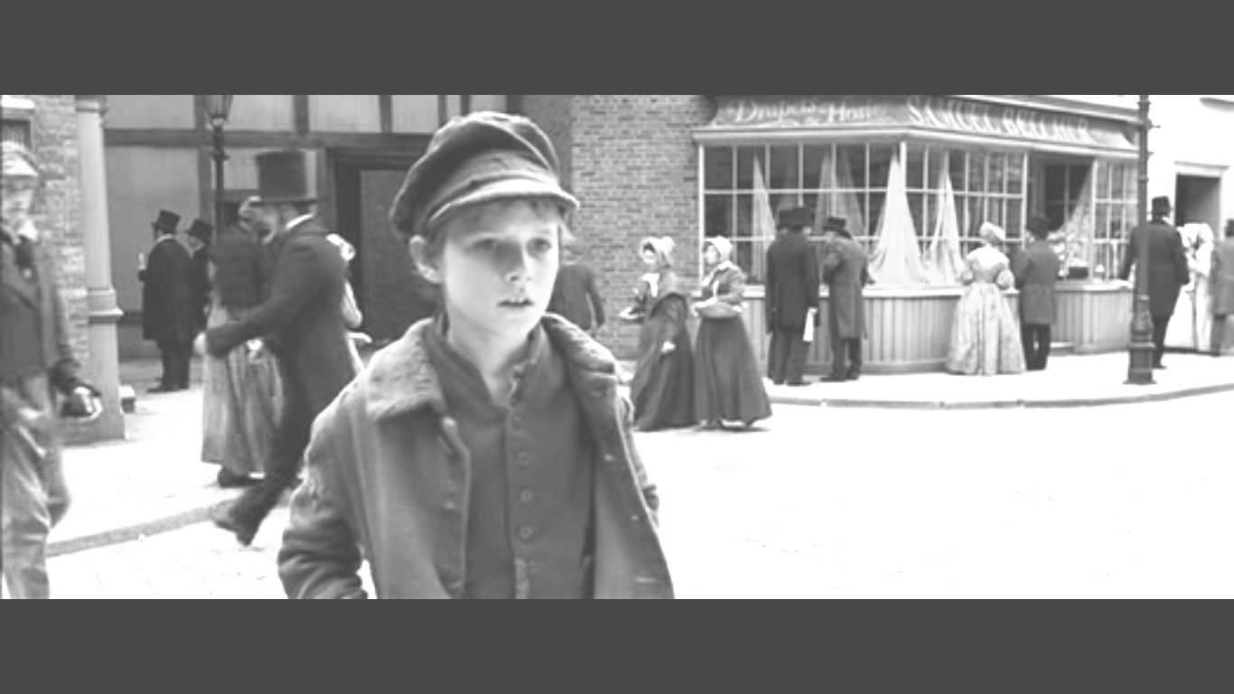

Chapter (5)
official | موظف |  |  | locket | قلادة
get better | يتحسن |  |  | criminal | مجرم
a coach | سيارة |  |  | cruel | قاسي
set off | يبدأ رحلة |  |  | an inn | فندق صغير
nervous | عصبي |  |  | slums | عشوائيات
wet mud | طين |  |  | disappointed | خاب أمله

When the weather became warm, Mrs Maylie took Rose and Oliver to her small holiday house in the country far from London, leaving Giles and the other servants to look after her usual house. Oliver loved his time there until one day when Rose became ill. Mrs Maylie looked very worried and Oliver realised she was crying. "My dear Rose, what will I do without you?" she sobbed. "Mrs Maylie, Rose is so young and so good that nothing bad will happen to her," said Oliver. "I hope you are right, Oliver," said Mrs Maylie. But Rose did not get better and the next day, Mrs Maylie asked Oliver to post a letter to Dr Losberne. "I have another letter here for my son Harry," said Mrs Maylie. "You can post this, too." Oliver set off across some fields and ran until he reached the nearest village where he could post the letters. He felt happier when he knew that help was on its way.

He turned round to go home when he walked into a nervous-looking man. "Sorry, sir, I did not see you," he said politely. "What are you doing here?" shouted the man. He had dark, cruel eyes and an angry expression. Oliver did not know if he was ill or mad, and he quickly ran back home. Rose did not seem any better and when Dr Losbeme visited, he did not seem very hopeful. He said he would stay with them to-look after Rose.
"She will sleep for a long time," Mrs May lie told Oliver. "Perhaps she will wake up better. But I am very worried that she will not wake up at all."

One morning a few days later, Dr Losberne left Rose's room and walked quietly up to Mrs Maylie and Oliver. "Is she dead?" Mrs Maylie sobbed. "No!" exclaimed the doctor. "I think she'll be up and about in no time." Mrs May lie and Oliver laughed with happiness. Oliver decided to go out into the countryside to get Rose some flowers. As he was returning, a coach stopped in the road next to him. Mr Giles looked out of the coach. "What news is there of Rose?" he asked. "It's good news," said Oliver. Then a gentleman got out of the coach and walked up to Oliver. Oliver was not sure if he was angry or worried. "Are you sure that the news is good?" he said. "Yes, sir. Dr Losbeme says she will be fine." The gentleman relaxed at once and smiled. Then he said, "Take the coach, driver. I'll walk to my mother's. Come with me, Mr Giles."

Oliver walked back with Mr Giles and the gentleman. He was about twenty-five and he looked very like his mother, Mrs Maylie. They soon reached the house and went inside, where Mrs Maylie was very pleased to see her son, Harry. "I got your letter yesterday, Mother," said Harry. "Why didn't you tell me Rose was ill before?" "I didn't want to worry you." "But you know how much I care about Rose." Oliver could see that Harry cared greatly for Rose. Every day, Harry brought flowers to Rose's room, and every day she became a little better. Meanwhile, Dr Losbeme became Oliver's teacher and he spent his time learning to read and write. Soon, Rose was completely better, and Oliver felt really happy for the first time in his life.

They had been at the holiday house for most of the summer and Oliver spent his time studying hard. In late August at the end of a hot day, Oliver fell asleep while he was reading a book. He had a terrible dream. He thought he saw Fagin and another man looking at him through a window. He woke up with a cry, and then realised that it was not a dream! There was Fagin with another man. It was the man who had shouted at him when he went to get the doctor. The men disappeared, and Oliver shouted out. Mr Giles and Harry ran up to help him. "It was Fagin!" cried Oliver. "Which way did he go?" asked Harry. Oliver pointed and the men ran after the criminals, but they could not find them anywhere. "Perhaps it was just a dream," said Harry. "No, I saw Fagin with the man I told you about," said Oliver. They asked people in the nearest village if they had seen anyone. No one had seen anything. The strange men were soon forgotten and Harry and Mrs Maylie prepared to go home. "You can write now, can't you?" Harry asked Oliver one day. "Will you write to me often and tell me how my mother and Rose are?" "Of course I will," said Oliver. "Don't tell anyone," Harry said.
That day, Harry and the doctor left in a coach. As Rose watched them leave from her window, she was crying. During the time that Oliver had stayed at Mrs Maylie's summer home, there had been changes at the workhouse where Oliver was born. The official who had been so cruel to Oliver, Mr Bumble, was now the master. He was also now married to Mrs Corney, the woman who had listened to Nurse Sally the night she died. After work one day, Mr Bumble went for a walk. It began to rain, so he went into a nearby inn until the rain stopped. Inside the inn Mr Bumble saw a tall stranger with dark, cruel eyes reading a newspaper. He looked at Mr Bumble. "You work at the workhouse, don't you?" he asked. "I'm now the master of the workhouse," said Mr Bumble proudly.

The man walked over to Mr Bumble's table and sat opposite him. "Good, then I'm sure you can give me some information," he said, passing Mr Bumble some money under the table. "Can you remember a time twelve years ago?" he asked. "A boy was born in your workhouse. He later worked as an apprentice, but ran away to London." "You mean Oliver Twist!" said Mr Bumble excitedly. "I don't want to know about him!" shouted the man. "I want to know about his nurse. Where is she?" "You mean Nurse Sally?" said Mr Bumble in surprise. "She died last winter." The stranger looked disappointed. "But she did say something to a person I know," said Mr Bumble, realising that the man could perhaps give him more money. "How can I find this person?" the stranger asked. "I can introduce you tomorrow," said Mr Bumble. "Bring the person to this address at nine

o'clock," said the stranger, giving Mr Bumble some paper. "Ask for Monks." He stood up quickly and then left. The next night, Mr Bumble and his wife travelled to a poor part of the town by the river. It was raining and Mrs Bumble looked nervous.

This was an area of slums where only the poorest people lived and she knew that many of them were criminals. The streets were narrow and covered in wet mud and the wooden houses were so old that they looked as if they could fall down at any time.
They stopped in front of an old factory and Mr Bumble looked again at the paper with the address on it. "It should be here," he said. "Hello there," called a voice. "Come in here." They walked through a door into the old factory, and there was Monks.

Mrs Bumble was pleased to leave the streets, although the inside of the factory was cold and dark. "So, you were with the nurse on the night she died?" Monks asked Mrs Corney, now Mrs Bumble. "What did she say to you?". "Perhaps you have some money for this information?" Mrs Bumble suggested. Monks put a bag of coins on the table in front of her.

Mrs Bumble then told Monks what happened on the night that Nurse Sally died. "She said that she took the gold locket? What more did she tell you?" 'shouted Monks. "She died before she could tell me any more," said Mrs Bumble. "What?" shouted Monks. "But after she died, I found this," she continued. She showed Monks a small leather bag, and inside it was the gold locket. Monks picked up the locket and opened it. Inside he could read the name "Agnes". "Is this everything that you wanted to know?" asked Mrs Bumble. "Yes," said Monks, closing the locket quickly and looking suddenly pleased. "Now look." He lifted a heavy door in the floor next to where they were standing. Under the door they could see the dark river running below them. Mr Bumble looked frightened. What was Monks going to do with them?

Questions with Model answers
1- Oliver was happy to do anything for Rose and Mrs Maylie .Discuss.
Oliver set off across some fields and ran until he reached the nearest village where he could post the letters .He felt happier when he knew that help was on its way.
2- Who did Oliver meet on his way back?
Oliver met Monks (a nervous – looking man with dark cruel eyes and an angry expression )
3- What did Oliver think of Monks when he met him ?
He didn't know if he was ill or mad, and he quickly ran back home.
4- What did Dr Losberne decide about Rose ?
Dr Losberne didn't seem very hopeful about Rose's case and decided to stay with them
5- How did Dr Losberne make Mrs Maylie and Oliver happy ?
Dr Losberne told them that Rose would be up and about in no time.

6 – When and where did Mrs Maylie take Oliver and Rose ?
When the weather was warm , Mrs Maylie took Oliver and Rose to her small holiday
house in the country far from London.
7- Who looked after Mrs Maylie's house?
Mr Giles and other servants looked after her usual house.
8-How far was Mrs Maylie worried about Rose?
When rose was ill , Mrs Maylie was so worried that she cried .
9- How did Oliver comfortيواسي Mrs Maylie when she cried ?
Oliver told her that Rose was so young and so good that nothing bad would happen to her.
10- To whom did Mrs Maylie send Oliver to post the letters ?
Mrs Maylie asked him to post a letter to Dr Losberne and another letter to her son Harry .
11- Why did Oliver decide to go out into the countryside ?
To get Rose some flowers
12-What did Oliver tell Mr Giles and Harry about Rose ?
He told Mr Giles that Rose would be fine
13- Who was Harry?
He was Mrs Maylie's son and he was about twenty-five and he looked very like his mother.
14-Harry cared very much for Rose .Explain .
Harry cared about Rose very much and he brought flowers to Rose's room every day
15-How was Dr Losberne helpful to Oliver ?
Dr Losberne became Oliver's teacher and he spent his time learning to read and write .
16- When did Oliver feel happy for the first time in his life?
When Rose was completely better .
17- What were the slumsالعشوائيات like ?
This was an area of slums where only the poorest people lived .Mrs Bumble knew that many
of them were criminals . The streets were narrow and covered in wet mud and the woodenhouses were so old that they could fall down at any time.
18- What did Monks give Mrs Bumble to give him information about the nurse?
Monks put a bag of coins in front of Mrs Bumble to tell him about what happened on thenight that Nurse Sally died
19 – What was written inside the locket?
Inside the locket there was the name Agnes ( Oliver's mother )
20- When did Mr bumble look frightened?
When Monks lifted a heavy door in the floor next to where they were standing. Under the
door they could see the dark river running below them.Mr Bumble looked frightened
about?
Harry asked Oliver to write to him about his mother ( Mrs Maylie ) and Rose.
21-What made Rose cry ?
Rose cried because she saw Harry leaving the house
22- What were the changes in the workhouse ?
The official who had been so cruel to Oliver , Mr Bumble , was now the master. He was also
now married to Mrs Corney .
23- What do you know about Mrs Corney ?
Mrs Corney was the woman ho listened to Nurse Sally the night she died.
24 – What did Mr Bumble tell Monks in the inn ?
Mr Bumble told Monks that he was the master of the workhouse
25-Why did Monks give Mr Bumble some money ?
Monks gave Mr Bumble some money to give him the information he wanted.
26-What kind of information did Monks want to know from Mr Bumble ?
He wanted to know about the nurse who was attending Oliver's birth
27-Why was Monks disappointed ?
Monks was disappointed because Mr Bumble tell him that Nurse Sally died last winter.
28-Why did Mr Bumble want Monks to meet Mrs Corney ?
Mr Bumble wanted Monks to meet Mrs Corney who the nurse told her something before her death.. Hoping to get more money
29- What did Monks ask him to do ?
Monks asked Mr Bumble to bring Mrs Corney to his address at 9 o'clock
30- Where did Monks meet Mr Bumble and his wife ?
At a poor part of the town by the river.

