3-How many atoms of lead are present in 41.4 gm of lead (pb=207)

4-What is the mass of 3 × 10²² carbon atoms (C=12)

Number of atoms =number of moles × 6.02 × 10²³

3 × 10²² = no of moles × 6.02 × 10²³

no of moles = 5× 10 ⁻²

mass = 5× 10 ⁻² ×12 = 0.6 gm

5- Calculate the mass of 0.25 mole of sodium carbonate (Na=23 ,C =12 ,O=16)

6-Calculate the no of moles in 132.5gm sodium carbonate (Na=23 C=12 ,O =16)


7-Calculate the mass of 0.5 mole of water (H=1 , O =20 moles

Calculations based on the balanced equation
EX: 1- Calculate how many moles of water vapour are produced from the reaction of 10 moles of oxygen and excess amount of hydrogen
2H₂ + O₂ 2 H₂O

2-calculate the mass of magnesium oxide which is produced from the combustion of 6 gm magnesium ribbon in air (Mg =24 ,O =16)
no of moles in 6 gm Mg = 6÷ 24 = 0.24 mole
2 moles (Mg) 2 moles (MgO)
0.25 moles x mole
x = 0.25 mole
mass of MgO = 0.25× 40 = 10 gm think in a another solution...? *** Another solution:
2Mg + 02 2MgO
2 moles 2moles
(2x24 ) 2 (24+ 16)
48 gm 80gm
6gm x gm
3-Calculatae the mass of zinc chloride produced from the reaction of 32.5 gm zinc with hydrochloric
Zn + 2HCL ZnCL₂
Number of moles in (32.5gm zn =mass of substance =32.5 = 0.5 mole
from the balanced equation : mass of one mole
Mass of substance = 0.5×(65×2(35.5) ) =68 gm

4-Calculate the number of chloride ions produced on dissolving 29.25 gm sodium chloride in water/ (Na =23 ,CL =35.5
Na CL Na + CL
Number of moles in. Na CL) = 29.25 gm from the balanced equation;
(23+35.5)

Number of ions = moles × 6.02 × 10 ²³
5-caculate the mass of magnesium oxide which is produced from the combustion of 6 gm magnesium ribbon in air (Mg =24 ,O =16)
Solution : 2Mg + O 2 2 Mg O
number of moles in 6 gm ÷ 24 = 0.25 mole from the balanced education :
2moles Mg 2 moles MgO
0.25 moles x
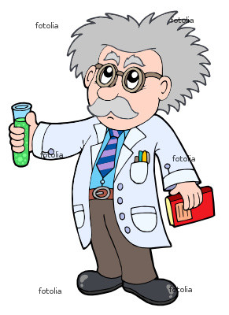
X = 0.25
another solution :
2Mg + O₂ 2MgO
2moles 2× 24 2×( 24 +16 )
48gm 80
6gm X gm
x = 10 gm
-How many hydroxide ions are produced on dissolving 18.5 gm of calcium hydroxide in water (Ca =40 ,O =16 ,H =1)
Ca(OH)₂ Ca++ + 2(OH)-
Number of moles in 18.5 Ca(OH)2 = 18.5 =0.25 mole
(40+2(16+1)

from the balanced equation 1 mole Ca(OH)2 2 mole (OH)
  - X
X =0.5 mole
Number of ions (OH) = Number of moles × 6.02 ×10 ²³
=3.01 × 10
23ions
How many moles of calcium ions in 222 gm calcium Chloride.
number of moles in 222 gm CaCL₂= mass of substance mass of I mol CaCL₂
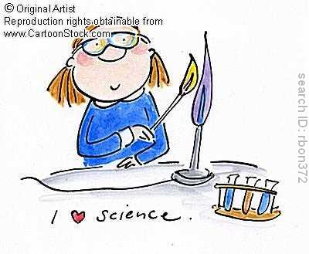
from the balanced equation :
1 mole (Ca CL₂) 2 moles CL
x mole CL

